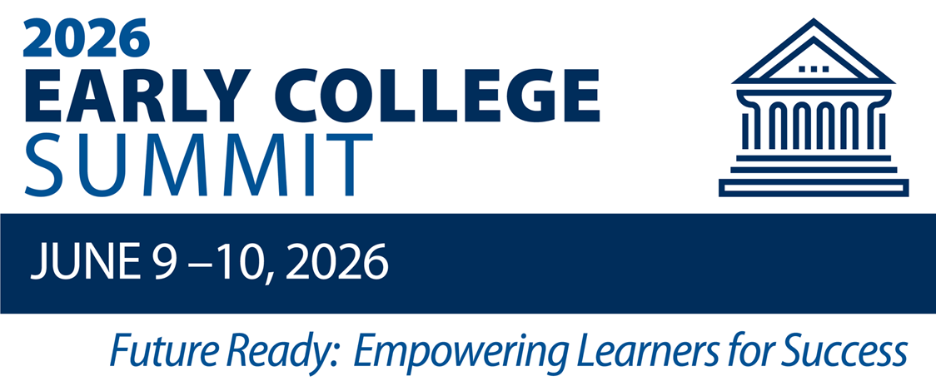
Summit Planning & Reflection Guide
for Teams & Individuals
Welcome to the 2026 Early College Summit! We are excited to partner in learning over the next two days! Please use this planning guide to capture insights you hear from speakers, attend interest sessions, network with fellow educators, capture ideas, and share learning with colleagues.

My Summit Goals & Aspirations
What do you want to walk away with from your Summit experience?
- What do you hope to learn?
- What connections dp hope to make as you network during the Summit?
- How will the Summit inspire you to prepare students to be Future Ready?

School Team / Organization Goals & Aspirations
What are the priorities of your school, program, and institution for the coming year?
What learning opportunities do you see in the Summit offerings that can help inform your collective work on these priorities?

My Interest Session Schedule:
Tuesday, June 9th
Time | Session Title | Room
10:45 – 11:45 am
1:00 – 2:00 pm
Wednesday, June 10th
Time | Session Title | Room
8:30 - 9:30 am
9:45 – 10:45 am
12:40 – 1:40 pm

Future Ready: Empowering Learners for Success
Tuesday, June 9th
- Capture your learning from the day’s speakers, interest sessions, and professional networking.
- Reflect on the implications of your learning for the upcoming school year.
Wednesday, June 10th
- Capture your learning from today’s speakers, interest sessions, and professional networking.
- Reflect upon and consider the implications of today’s experiences on the upcoming 2025-26 school year.

Synthesis & Next Steps:
- Capture Summit learning for adoption, adaptation, and implementation within your school, program, or organization.
- Identify specific action steps you can take to translate Summit learning into practice.

