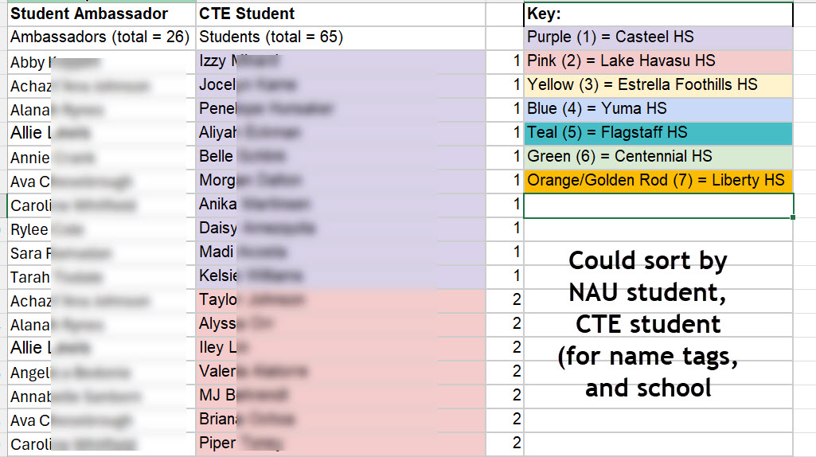
Email sent to students recommended by faculty
[Faculty name] recommended you to be a student ambassador at TARIAT this year!

First, make sure you are registered for the TARIAT Conference on Friday, 3/27/26
Here’s the registration link, just in case you need it: https://www.eventbrite.com/e/2026-tariat-theres-a-reason-im-a-teacher-tickets-1982022419411

Second, for the first time ever, we have 91 high school students attending TARIAT. These students are part of “education professions” CTE programs in high school and will be on campus for an all-day field trip with their teachers. We are looking for welcoming college students to serve as ambassadors.

As a TARIAT Ambassador, you would leave the second breakout session a few minutes early and lead a small group of high schoolers (4–5 students from various schools) to the Hot Spot for lunch. The goal is for them to eat with you, ask questions, and make connections. After lunch, you’d walk them back to Eastburn for their afternoon sessions, and then you’re free to attend your third breakout session.

Please let me know if you are interested!

Email sent to students who replied with interest
Thank you so much for expressing your interest in being a student ambassador for TARIAT this year! I wanted to let you know that I have your name and I will be sending you more information after spring break.

Make sure to take time to recharge this week! So important for work/life balance and to prevent burnout as a student and as a teacher!

Email sent to student ambassadors week before conference
Please read all information carefully and reply with requested RSVP information
Thank you for volunteering to be a TARIAT student ambassador this year! You will be an important part of the day for our high school CTE students attending TARIAT. This is our inaugural ‘conference within a conference’ and your role has been intentionally crafted. The CTE high school students are coming from 7 different schools and are part of the Education Professions program at their school. They are interested in careers in education.

Your Role
You will be eating lunch with an assigned group of 2-3 high school students (see attached list, it is alphabetically by first name). We have intentionally created these groups to mix the high school students so they are not eating with peers from their own school. This will allow the CTE students to have a chance to talk one-on-one with one of you (NAU student) to learn more about NAU and your experience at NAU.

Preparation Required
We are asking each NAU ambassador to make a decorated sign with their name (8 ½ x 11 cardstock or file folder). Be creative! If you need materials they can be provided to you.

Logistics
- You will need to leave your TARIAT breakout session early at 11:30 am and proceed to the grassy area right outside COE Room 190 (presenters have been notified that this will occur).
- High school students will come outside ~11:40-11:45.
- Hold up your sign so it is visible.
- High school students will have their assigned NAU ambassador on their name tag, they will come find you.
- Once you have your entire 2-3 person group, you will walk over to the Hot Spot and have lunch with your group (tickets provided by NAU for you and the HS students).
- At 12:40 high school students will need to meet up with their school chaperones outside of the Union (exact location TBD). Please allow time for (and direct students to) bathroom/water refill if needed. They will be doing a 1-hour walking tour of campus after lunch. Please do not leave your students until they meet up with their school group.

RSVP
Please reply (*not* reply all) to this email with your RSVP that you will still be able to be a student ambassador for the event. If you need materials to make you sign, please indicate in the email. Please provide a cell phone number where you can be reached on the day of the event if necessary.

Thank you again so much for being involved in this experience! We appreciate your willingness to be an ambassador! My cell phone is 520-510-5246 if you need to reach me for any reason (including emergency schedule changes).

Email sent to student ambassadors day before conference
We are looking forward to your participation as a student ambassador at TARIAT tomorrow! Attached is REVISED list of student ambassador assignments. Your HS students will find you. Please be outside in grass near room 190 by 11:35 am.

Don’t forget to make a sign with your name on it.
- 8 ½ x 11 card stock (or similar material)
- First name
- Decorate!

The library makers-lab has supplies for decorating including card stock (they are open until 2 am today/tonight)

My cell is 520-510-5246. Please TEXT ME if you have any questions or issues.

