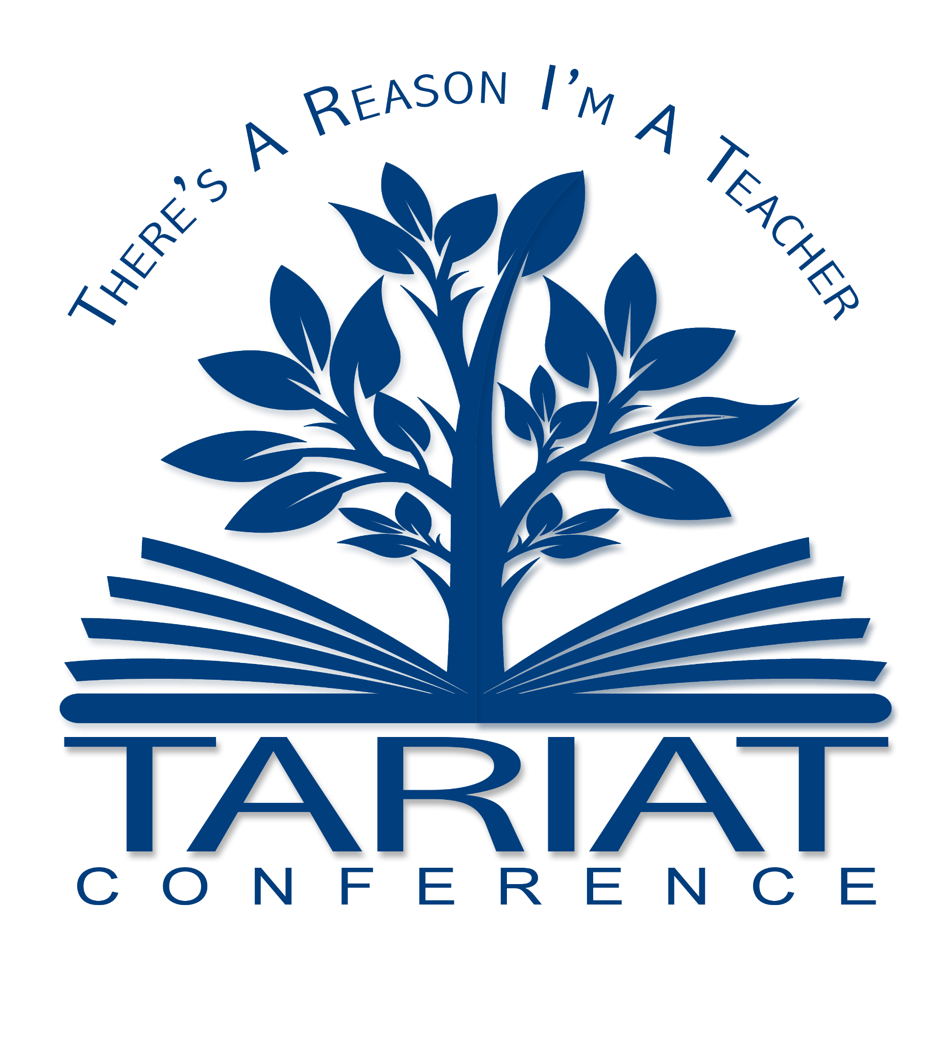
Friday, March 27, 2026
CTE - AGENDA
8:00 am | Registration & Breakfast | COE room 190
8:45 - 9:30 | Opening Session  ~ Welcome: Dr. Annie Watson & Josh Meibos  ~ Opening Message: Dr. Mellott, Dean  ~ Keynote:  Tiffany Jaseph, 2026 Arizona Teacher of the Year | Cline Library Auditorium
9:45 - 10:00 | Teacher NAU Pathways Presentation | Cline Library Auditorium
10:15 - 11:40 | Centers for K12 Students  (see back for details) | COE rooms  189 & 190
11:45 | Meet the NAU Student Ambassadors | COE room  190
11:50 - 12:45 | LUNCH - HOT PASS | UNION
12:45 | Campus Tour
2:15 | NAU-Access to Scholarships and Financial Aid & Q&A | Cline Library Auditorium
2:45 - 3:30 | Closing Session  ~ Keynote:  Ashlie Crosson, 2025 National Teacher of the Year  ~Prizes | Cline Library Auditorium
Check Out the Center Activities on the Back!
Thank You!

Station/Room | Presenter/Dept/ | Title | Description
1  Rm. 190 | Teresa Toraason-  T & L | Classroom Management Chatterbox-  “Why do they do that?” | Come and explore the function of student behaviors! Explore the four functions of student behavior through a hands‑on activity. Participants will choose strategies for each function and create a paper chatterbox (fortune teller) to reinforce practical tools for understanding and responding to behavior.
2  Rm. 190 | Angie Hansen-  Secondary English | Reading and Writing Your World: Teaching Secondary English Language Arts | Students will discuss what they love about English Language Arts and create a “mini-book” to take home that focuses on a theme related to teaching ELA based on their own interests and experiences.
3  Rm. 190 | Jacob Lesandrini-  First Year Seminar | Building the Best Teachers | Using random LEGO pieces, students will build a 3‑D model of what they believe makes a “best teacher.” Participants will share their creations and reflect on the characteristics that support strong teaching and learning.
4  Rm. 190 | Ceci Chaffin-  T& L | Remember Learning to Read? Try It Again | Using a symbol-based alphabet, students attempt to decode a short passage—no prior knowledge required. The frustration and triumph they feel mirrors the real experience of beginning readers, offering a powerful reminder of the patience and clarity great teaching requires.
5  Rm 190 | Christi Carlson- Secondary History | Garbology:  How do we know what we know? | Students become detectives as they analyze modern “garbage” to infer information about its owners. This hands‑on investigation introduces key historical thinking skills such as bias, perspective, and evidence while exploring the question, “How do we know what we know?”
6  Rm. 189 | Monique Martinez  T& L | Your Teacher Heart | Students will create a heart collage with items, words or stories that identify their teacher heart and why.
7  Rm. 189 | Haze Moss-  Early Learning Development Center | Loose Parts, Big Ideas: Experiencing Inquiry-Based Learning | Participants will engage in open‑ended loose‑parts play using simple materials, exploring, building, and creating freely. This hands‑on experience demonstrates how unstructured provocations spark curiosity, engagement, and student‑driven learning.

Friday, March 27, 2026
STANDARD AGENDA
8:00 am | Registration & Breakfast | COE room 190
8:45 - 9:30 | Opening Session  ~ Welcome: Dr. Annie Watson & Josh Meibos  ~ Opening Keynote: Tiffany Jaseph  2026 Arizona Teacher of the Year  ~ Opening Message: Dr. Dean Mellott | Cline Library Auditorium
9:45 - 10:45 | Breakout Session #1 | COE Classrooms  200 - 216
10:55 - 11:55 | Breakout Session #2 | COE Classrooms  200 - 216
12:00 - 1:15 | LUNCH - HOT PASS | UNION
1:30 - 2:30 | Breakout Session #3 | COE Classrooms  200 - 216
2:45 - 3:30 | Closing Session  ~ Keynote: Ashlie Crosson  2025 National Teacher of the Year  ~Prizes!! | Cline Library Auditorium
Thank You!
Survey

