- Identify Your Need  Before casting your line, define what you are trying to catch and why | - Survey the Waters - Channels  Where will you "fish" for this specific need? Check all that apply: | 3: Identify Your "Big Fish"  Brainstorm 2–3 businesses, organizations, or individuals in your local community:
Program Need: Guest speakers, career fair, internships, mentorships, advisory  Target Industry: Healthcare, Construction, IT, Arts/Design) - review the CTE Cluster and cross-reference on O*Net for related career paths  ______________________________________________  ______________________________________________  ______________________________________________  ______________________________________________  ______________________________________________  ______________________________________________  ______________________________________________ | The "Hidden Stream": Alumni is often the most underused resource for partnerships.  Where can you find or track your alumni?  _____________________________________  Community Hubs: Chambers of Commerce, YMCA, Recreational Districts, local and state government, local colleges and universities.  Online Networking: LinkedIn, Facebook groups, Nextdoor, or local community websites.  In-Person Events: Local, Regions, and National conferences, community meetings, music/arts festivals, farmers markets, sporting events  Professional Groups: Chambers of Commerce, networking clubs, and Industry-specific associations: https://www.careeronestop.org/Toolkit/Training/find-professional-associations.aspx  ______________________________________________ | - _______________________________________  - _______________________________________  - _______________________________________
4: Prepare the Bait  (The "Why" & Marketing Strategy)  How will you market this need so partners see the value in authentic engagement? | 5: Casting the Line  (The Action Plan)  Determine your first point of contact and how you will connect and engage. | Next Action Steps:
The Value Proposition: Why should they join? (Building their talent pipeline, giving back to the community, or sharing industry insights).  The Hook: Draft a one-sentence "pitch" that focuses on their needs/motivations.  Draft: "I’m looking for [Industry] experts to [Specific Activity] because your insights would [Benefit to Partner/Students]."  Template Folder  __________________________________________________________________________________________________________________________________________________________________________________________________________________________________________________________________________________________________________________________________ | Method:  Cold Call  Email  LinkedIn Message  In-Person Visit  Request introduction from common connection  Commitment to the Relationship: How will you show sincerity and maintain the connection?  Examples:  - Follow up within 48 hours for all emails  - Send calendar invites for events  - Send reminder emails 2 days before events  - Double check arrival and departure times so they don’t come right at passing periods  - Be present  - Consider the space they need in an environment they are unfamiliar with  - Ask to learn more about their work and how to support what they do  ____________________________________________________________________________________________ | Next Action Steps:
Resources and Additional Notes:

Shared Folder Resources for Session
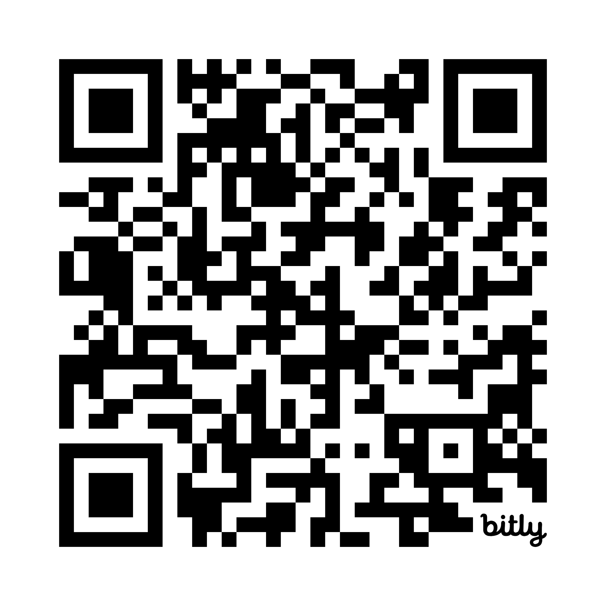
https://bit.ly/letsgofishwbl

