Critical Attributes for LifeSkills Classroom
Teacher: |  | School:
Observer: |  | Date:
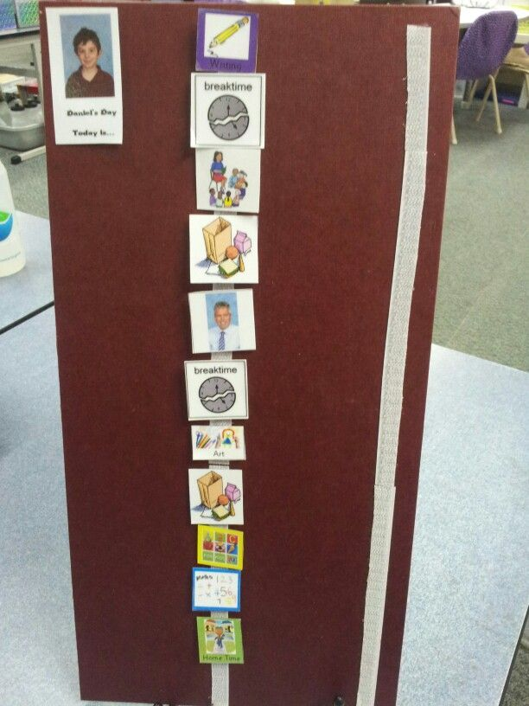
Classroom Structure/Management |  |  |  |  |  |  |  |  |  | Check if observed
Classroom stations are clearly labeled and defined by visual boundaries (furniture, desks, rugs, tape, etc.) to reflect what happens in each location. Include: Direct Instruction, Independent Work, Break, Group Instruction, Technology, Play/Leisure
A daily classroom schedule is posted for overall classroom structure that includes: teacher schedule, para schedules, and station rotations.
Teacher creates and manages an effective and efficient paraprofessional schedule.
Classroom is organized and materials are stored appropriately in containers, cabinets, and shelves.
Timers are used regularly to maintain continuity in station rotations.
v Each student has own interactive “strip schedule” or written schedule that aligns with the student’s functioning:
- Reflects minimal unstructured time and high levels of engagement.
- Age appropriate balance of work preparation and functional skills (social, leisure, daily living, self-care, etc.).
- Includes a variety of instructional arrangements (1:1, small group, large group, etc.).
- Symbolic representation (written, picture, object, etc.) for schedules.
Classroom routines are posted, used, and reinforced for: arrival, dismissal, checking schedule, waiting your turn, break, restroom,
each station, cool down, snack, community-based learning settings, and work sites
Communication systems are evident in the classroom setting, including low tech (e.g., core board) and high tech devices.
v Classroom manipulatives, sensory items, fidgets, and curriculum are organized, accessible, and used.
Each student has a structured daily parent/teacher communication system.
v There is evidence of data collection and documentation in the classroom environment (i.e, data sheets, tallies)
Reinforcement Systems
Complete reinforcement surveys for each student.
Based on the results of reinforcement surveys, create and use reinforcement menus for each student.
v Reinforcement systems are used by all adults regularly and consistently. Must use token boards or a similar technique.
All students earn reinforcement frequently and regularly.
v All staff provide high levels of specific appropriate praise.
v Inappropriate student behavior is redirected, ignored, or otherwise addressed according to each child’s needs.
Dynamic Instructional Program
v Teacher drives instruction and observes every environment regularly.
Instruction is provided using station rotations.
Regularly use district curriculum resources, including TeachTown.
v Teacher uses IEP-based lesson plans to organize direct instruction at the teacher table to target goals.
v All adults actively engaged in instruction.
v New skills are taught through direct instruction provided by the teacher.
v Materials are prepared, relevant, age appropriate, and reflect student interests.
v A variety of teaching strategies are utilized, including errorless learning, discrete trial, hand under hand, activity routines, etc.
v Appropriate “wait time” is observed following verbal input to allow students to process sensory input.
v All class activities, including leisure time, will be structured with the use of timers to increase student independence.
Create and use the following visuals: interactive student schedules, reinforcement menus, choice board, first/then tool, “I am
working for” tool, visual cards to pair with verbals, routine steps, designated stations, staff schedule

