 | SCALE SMART  Initiative Foundation 2026 Mini Summit

Growing Your Business without Losing Your Foundation
Audience workbook | Sarah Sengupta, PhD | August 27, 2026
Scale smart means building an operating system that can deliver more value without losing quality, cash resilience, team capacity, or purpose.
CUSTOMER | A repeatable promise
PROCESS | Work that flows
PEOPLE | Capability at the right level
ECONOMICS | Margin and cash resilience

My definition of smart scale
________________________________________________________________________________
________________________________________________________________________________
________________________________________________________________________________

SCALE SMART
Initiative Foundation 2026 Mini Summit

1. Scale-Readiness Scorecard
Score 1 = fragile, 3 = workable, 5 = repeatable under pressure. Add evidence, not optimism.
Area | Ready looks like | Score | Evidence / next step
Customer demand | Validated and likely to repeat | 1 2 3 4 5
Unit economics | Margin and cash timing visible | 1 2 3 4 5
Core workflow | Documented and measurable | 1 2 3 4 5
Capacity | People, tools, suppliers, and managers can flex | 1 2 3 4 5
Decision rights | Authority and escalation are clear | 1 2 3 4 5
Capability | Skills exist or can be built quickly | 1 2 3 4 5
Data | A few measures reveal flow, quality, margin, and learning | 1 2 3 4 5
Purpose fit | The opportunity strengthens the customer promise | 1 2 3 4 5
Lowest score = current scaling constraint: ______________________________________________

SCALE SMART
Initiative Foundation 2026 Mini Summit

2. Map One Real Order
Trace a recent request from first signal to cash. Mark waits, rework, owner decisions, and missing data.
LEAD | QUOTE | DELIVER | QUALITY | BILL | LEARN

Constraint prompts
☐ Where does work wait or queue?
Notes: _________________________________________________________________________
☐ Where does work return for correction?
Notes: _________________________________________________________________________
☐ Where must the owner or one expert intervene?
Notes: _________________________________________________________________________
☐ Where are standards unclear?
Notes: _________________________________________________________________________
☐ Where are you blind to time, quality, cost, or demand?
Notes: _________________________________________________________________________

Constraint statement
We cannot reliably scale __________________ because _____________________________________
The smallest reversible experiment is: __________________________________________________

SCALE SMART
Initiative Foundation 2026 Mini Summit

3. Build Capability, Not Just Headcount
Readiness depends on what people bring, how they convert knowledge into action, and what the organization provides.
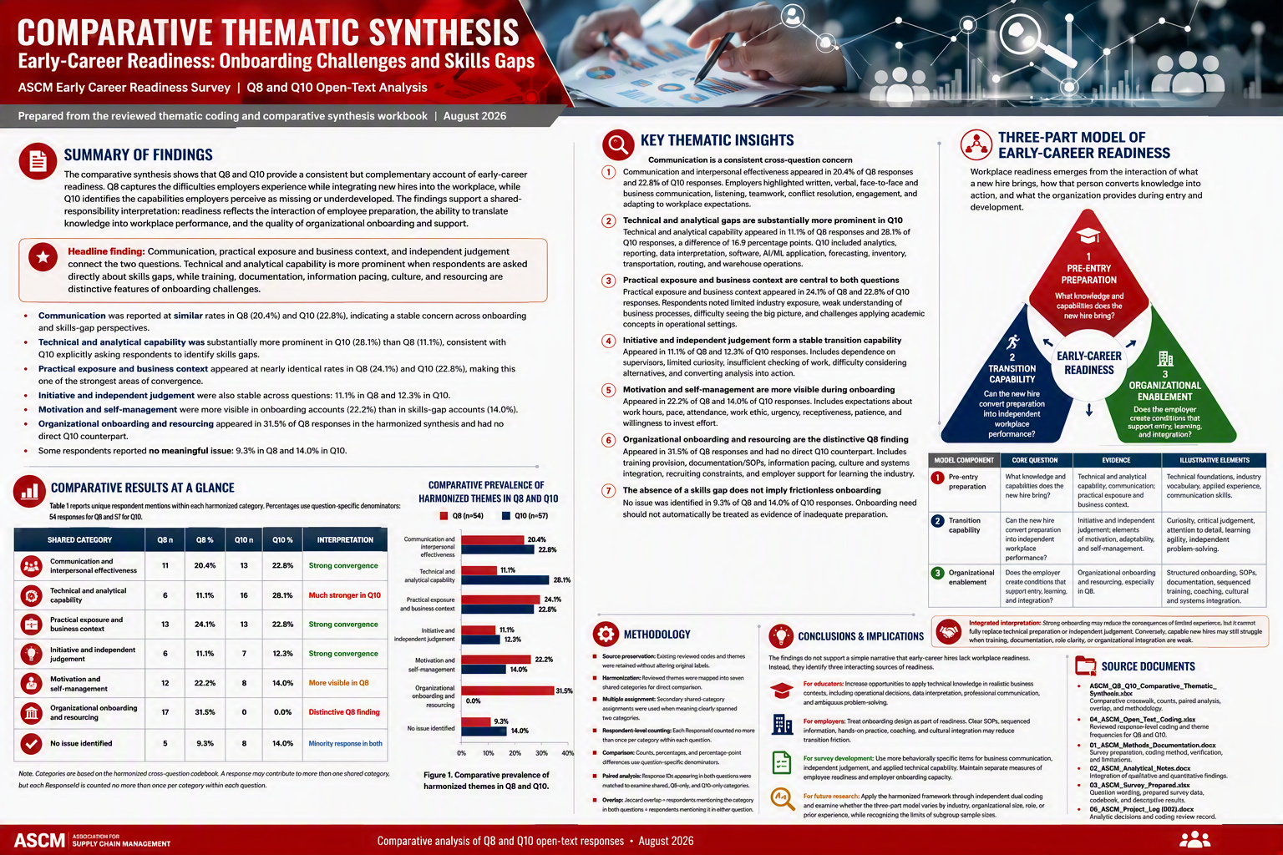

Which element is your growth plan assuming will “take care of itself”?
________________________________________________________________________________
________________________________________________________________________________
DEFINE | Critical work and performance standard
PRACTICE | Hands-on, job-relevant application
COACH | Fast feedback at the point of work
MEASURE | Quality, speed, judgement, and transfer
REPEAT | Integrate learning into the operating rhythm

SCALE SMART
Initiative Foundation 2026 Mini Summit

4. Opportunity Filter
Score each opportunity 1–5 and state the evidence.
Criterion | Question | Score | Condition for yes
Strategic fit | Strengthens purpose and customer promise | 1 2 3 4 5
Economic fit | Improves margin and cash resilience | 1 2 3 4 5
Capacity fit | Can be delivered without breaking quality | 1 2 3 4 5
Capability fit | Skills exist or can be built quickly | 1 2 3 4 5
Reversibility | Can be piloted, paused, or exited | 1 2 3 4 5
GO if: ________________________________________________________________________
PILOT if: ________________________________________________________________________
NO-GO if: ________________________________________________________________________

What must remain true even if the business doubles?
________________________________________________________________________________
________________________________________________________________________________
________________________________________________________________________________

SCALE SMART
Initiative Foundation 2026 Mini Summit

5. Your 90-Day Scaling Experiment
Choose one constraint, one learning target, and one reversible move.
Window | Focus | Actions | Evidence / gate
0–30 | DIAGNOSE | Baseline margin, cycle time, quality, capacity, and skill risk
31–60 | PILOT | Test one segment, workflow, offering, or team
61–90 | DECIDE | Scale, adapt, or stop based on evidence

My 7-day commitment
In the next 7 days, I will ______________________________________________________________

RASP partnership pathway
BRING | A growth constraint, skill need, data question, or innovation idea
CONNECT | Faculty expertise, research, grants, instructional design, PACE, and learner talent
BUILD | A diagnostic, pilot, customized training, applied project, or funded partnership
LEARN | Use evidence and feedback to improve, scale, adapt, or stop
A challenge I would like to explore with RASP: ___________________________________________
________________________________________________________________________________
Sarah Sengupta, Ph.D. | Associate Dean (Interim)
Research, Advanced Studies, and Partnerships (RASP)
419.574.2213 | sarah.sengupta@stcloudstate.edu | stcloudstate.edu

