Matt Conover
Vice President, Disney Live Entertainment
Disneyland® Resort

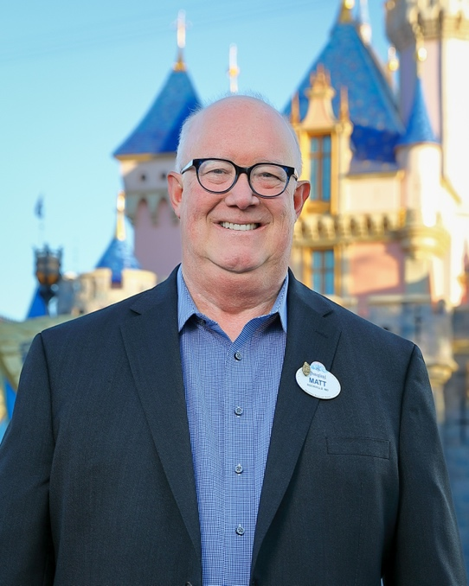

As vice president of Disney Live Entertainment at Disneyland Resort, Matt is responsible for a diverse team of professionals in the creation, development, production, delivery and sustainment of a wide variety of productions— from parades and stage shows, to nighttime spectaculars, entertainment atmosphere and world-famous Disney Characters.

Previously, Matt was vice president of Project Design and Delivery for Disney Live Entertainment at Walt Disney Imagineering. In his role, Matt led a team of more than 200 entertainment professionals and was responsible for the design, development and production delivery for world class projects around the world.

Matt joined Disney in 1989 as a stage technician at EPCOT and, two years later, joined the Disneyland Paris grand opening team as a production manager. In 1996, he joined Disney Cruise Line as a senior show producer where he produced three original new musicals for the Disney Magic and Disney Wonder ships. After, Matt served in several executive entertainment roles at Walt Disney World Resort, including general manager of entertainment at Disney’s Hollywood Studios and director of planning and production for Walt Disney Entertainment. Matt joined the Disneyland Resort team in 2005 as vice president, Entertainment and in 2009, became vice president of Creative Entertainment at Walt Disney Imagineering.

Some of Matt’s favorite accomplishments across his Disney career include being the executive producer for large scale special events like the christening of the Disney Fantasy cruise ship, the grand opening of Aulani, A Disney Resort & Spa and the grand opening of Shanghai Disney Resort.

Matt currently serves as chairman on the National Board of Trustees for the Educational Theatre Foundation. Matt earned his Bachelor of Fine Arts from The State University of New York (SUNY), Purchase College, in theatre design and technology with a concentration in lighting design. He lives in Orange County.

