New Outlook Quick Reference Guide
5 New Outlook Features That Save Time
Kathryn Avent-Mann

1. Create and Use Email Templates

Best for: Intake follow-ups, appointment reminders, document requests, and other repetitive emails.
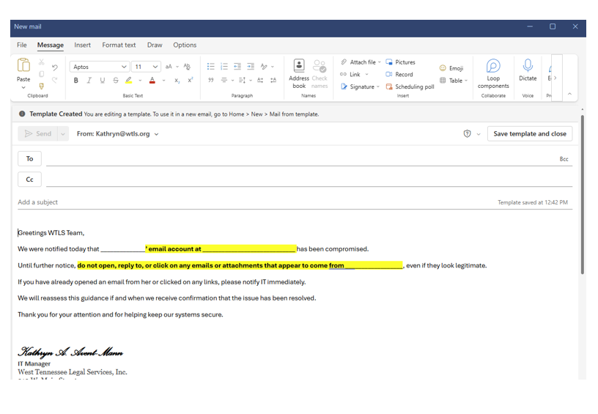
Create a Template
- Open a new email.
- Type the message you want to reuse.
- Select Apps from the ribbon.
- Open My Templates.
- Select + Template.
- Give the template a name.
- Save.

Use a Template
- Open a new email.
- Select Apps.
- Open My Templates.
- Choose your template.
- Edit as needed and send.

✅ Time Saver: Eliminates retyping frequently used messages.

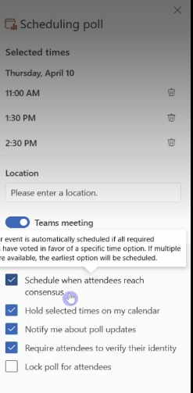
2. Schedule Meetings Faster

Use Scheduling Assistant
- Create a meeting invitation.
- Select Scheduling Assistant.
- Compare participant availability.
- Choose an open time slot.

✅ Time Saver: Reduces back-and-forth scheduling emails.

3. Use Categories to Organize Email

Categories provide visual organization without moving messages into folders.

Create a Category
- Right-click an email.
- Select Categorize.
- Choose a color or create a category.

Suggested Categories
🟥 Priority/Urgent
🟨 Action Required
🟦 Waiting On
🟩 FYI/Read Later

✅ Time Saver: Instantly identify what needs attention.

4. Display Multiple Time Zones

Add Additional Time Zones
- Open Settings.
- Select Calendar.
- Select View.
- Add additional time zones.

✅ Time Saver: Avoids manual time conversions.

5. Search More Effectively

Try searching using:
- Person's name
- Subject keywords
- Attachments
- Date ranges
- Natural language phrases
Examples:
- "emails from Bob last month"
- "budget spreadsheet"
- "meeting about governance"

✅ Time Saver: Find information faster without digging through folders.

Final Tip

If New Outlook seems different, start by adopting one feature.

LS5: What's New, What's Moved, What's the Same

The Same
✅ Cases
✅ Clients
✅ Notes
✅ Documents
✅ Reports
✅ Data

Different Locations

Looking For | LS5 Location
Actions | Rocket Icon 🚀
Time Entries | My Time Widget
Case Information | New Case Profile Layout

New Feature

✅ Built-in Timer

Allows users to track work as it occurs instead of estimating later.

Remember
The functionality hasn't changed. The location has.
The data stays the same.

