Inventory Through Polaris Weeding Workflows
BALDWIN PUBLIC LIBRARY

SAM HOLLO & CAMERON ROONEY-CRAWFORD

2026

Acknowledgements

Many thanks to Diana Ancog, Nadia Bertala, Wren Drisko, Megan Gusho, Jenn Halpern, Sebastian Hernandez, AJ Jawad, Emma Moskovitz, Cheyenne Nierhaus, and Grace Noble, our dedicated Paging team, for their many hours workshopping this inventory process.

Many thanks as well go to those power contributors on the IUG Discord; as well as to Julia Bedy on the Polaris Support Team, for persistence in troubleshooting our back end.

Preface

Baldwin’s inventory is a recombinant teleological process; with reporting and data accrual being continual over periodic in output (we argue the periodic approach is a poor model for extrapolation of data, and presents prohibitive logistical challenges for a larger library - closure, number of staff required to inventory, and so forth).

Forgive the roughage in our CCL and SQL (and feel free to offer more efficient writeups… keeping in mind the Find Tool’s ill-defined limitations).

Lastly, 8.0 has a known bug which prohibits the creation or addition of inclusion criteria to weeding templates—this is corrected from 8.1 onward. As such, the goldilocks zone for this inventory process is between 7.4 and 8.0.

Phase 0: Setting up Weeding Templates with an eye for ‘correct’ item/bib records

Following the intended weeding workflow from 7.5 onward, staff create a new weeding template in Leap for the collection to be inventoried. At Baldwin, we have a stockpile of templates for each collection at the ready, which took a few hours to pull together. Make sure to give the template a clear name (for example, “AS LP Fiction Inventory”), appending the date of creation and staff initials to the same field (that future inventory staff may more readily know when the template was last modified). We’ll come back to this in Phase 2.

Once the weeding template is set up, it is on to the inclusion criteria work form. Select “add criteria” to generate a new criteria form, before utilizing the Find Tool to generate the CCL--Common Command Language--query that will serve as our item and bib ‘scan’ for the ideal record of a given collection. We will not be using the item filter fields lower on the form.

To generate a CCL, or Power, search, use the basic search function and apply all filters desired. After getting your basic search results, make the jump over to the power search function and you will get an output of the CCL statement to copy (like so, though exceptions obviously abound):

(COL = __) AND ((BC = "31552*") AND ((CALL = "_") AND ((CS = 1) AND ((DIP = 1) AND ((HASBLOCK = 2) AND ((HASNOTE = 2[or 1 if a non-public note is part of this collection]) AND ((MAT = {list}"_"{/list}) AND ((NONCIRC = 2) AND ((SHELF = _) AND ((STAC = _) AND (TOM = {list}"_"{/list})))))))))))
Enter this data into the inclusion criteria field, test your criteria to, then select save - by which time one is essentially at the ready for inventory.

Due to a 400-character limit in the inclusion criteria field—and their exclusive ‘OR’ versus ‘AND’ relation to one another—more complex parameters will have to use multiple criteria work forms in the same template, as in the following, admittedly superlative sample:

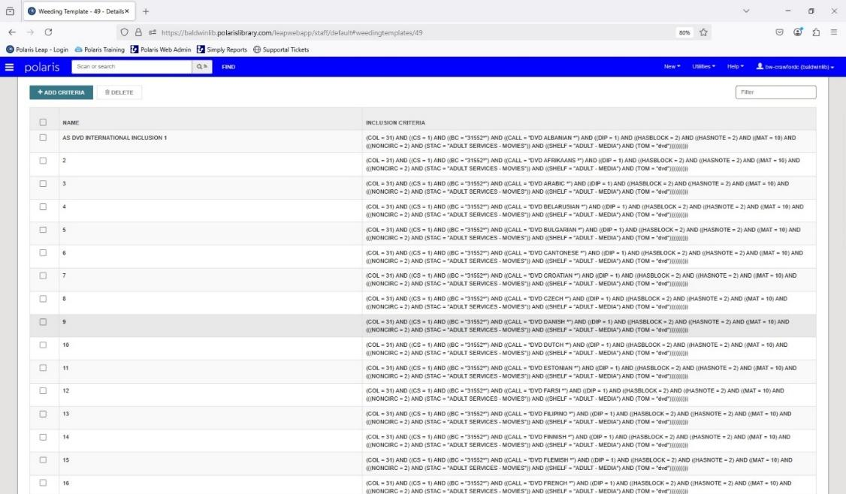

The rows go down to 49 distinct set of criteria being measured, which may seem excessive - however, we can attest that even at this number the amount of time between scanning an item and Polaris going through each inclusion is a mere matter of seconds (ample time for visual inspection of the item during inventory proper).

This initial process can be tricky and tedious; familiarization with CCL, however, is an incidental gift to those of us with little prior experience.

As standards for a given collection develop, you will inevitably have to update the inclusion criteria of a given template – customizability being a major feature of this manner inventory. Any time an adjustment is made, however, a new record set for the inventory of a given collection has to be made, as previously created record sets do not auto-update to reflect changes in the weeding template.

Okay. We have the technology. Now we are ready to cross the threshold and hit those stacks!

Phase 1 - Generating weeding-type record sets with inventory-focused weeding templates

Generate a new weeding-type record set, using the naming convention of your correspondent weeding template.

The notes field here will directly relate with your log method of choice (preferably cloud-based), that staff will be able to keep track of progress through a given collection.

Staff are now fully prepared to inventory.

Using a mobile workstation with a laptop and USB scanner, inventorying staff go item by item on the shelf, visually inspecting the materials for structural damage, as well as physical labeling errors. If the item at hand is in satisfactory condition, they then scan the barcode and let the template do its work; checking the item and bib record for matches on all good item data. If anything does not match up, a red toast will appear:

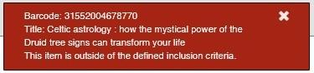

or

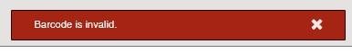

Staff then know to set the item aside for further supervisorial inspection and correction. In such manner they work their way through a given collection, updating the notes field and corresponding inventory log as to the last item checked. The next staffer carries on this relay, eventually concluding inventory’s initial, generative phase.

As a whole, item or bib-level exclusion are fairly straightforward and easy to spot. However, there can be myriad problems requiring a much closer look (problems which the toast, alas, does not point to--so be prepared to dust off that hunter’s cap and magnifier).

By way of example, in our DVD collection we have numerous items twenty-plus years old. Their material type at the bibliographic-level was set to “laser disc” - an honest enough mistake twenty years ago, and of some technical validity… But obviously incorrect, and difficult to readily surmise when they were brought to us by inventory staff.

As bibliographic-level errors can be extremely challenging to discern (who would have guessed an incorrect speed of playback entry byte could exclude audiobooks?), those less concerned with this level of catalog correction can simply remove the TOM inclusion criteria.

Phase 2 - “Wherefore are thou, ‘In’ status items?” -- Generating item-type record sets for those items ‘In’ but roaming

At this stage, we’ve typically scanned more than half of a collection - but accounting for 50-70% of anything is hardly comprehensive (and certainly unworthy of being claimed as inventoried). What of the items that are currently ‘In’ (or at least, supposed to be) that were missed during initial inventory?

As with panoramic photography, things can and will move behind the point of capture; items that were checked out during inventory will have come back and gotten shelved, mis-shelved materials may have found their proper place once more, and so forth. To fill out our picture, we’ll have to go over the space again - working somewhat closer to familiar ‘snapshot’ models than our earlier, generative process.

It’s time for some SQL. Run the following in the Find Tool, replacing int values with relevant information:

Using RecordSetID:

SELECT ItemRecordID
FROM CircItemRecords cir
INNER JOIN ShelfLocations sl
ON sl.ShelfLocationID = cir.ShelfLocationID
WHERE sl.Description NOT LIKE '%NEW%'
AND AssignedCollectionID = int
AND ItemStatusID = 1
AND ItemRecordID NOT IN
(SELECT ItemRecordID
FROM WeedingRecordSets
WHERE RecordSetID = int
)

Using the weeding record set name:

SELECT ItemRecordID
FROM CircItemRecords cir
INNER JOIN ShelfLocations sl
ON sl.ShelfLocationID = cir.ShelfLocationID
WHERE sl.Description NOT LIKE '%NEW%'
AND AssignedCollectionID = int
AND ItemStatusID = 1
AND ItemRecordID NOT IN
(SELECT ItemRecordID
FROM WeedingRecordSets wrs
INNER JOIN RecordSets rs
ON rs.RecordSetID = wrs.RecordSetID
WHERE rs.Name = 'nvarchar(80)')

Generate an item record set from these results, following the naming conventions used for the weeding templates and weeding record sets.

With this record set, staff can return to the collection first inventoried and search for the corresponding items – now merely checking physical condition and whether the item details match the display in the item record set. If they are unable to find an item, staff tick the box to the left of the material and continue down the list, until they reach the end.

Concluding their search, inventory staff will send the ticked items to a new record set, named something along the lines of “[Collection name] Inventory - ‘In’ Items NOS [datetime] [staff initials]”. They will then remove the items from the phase 2 record set.

As for the remaining materials… we need to find a way to have the weeding template scan them for deeper cataloguing errors. And for this we will use export and import functions in both item and weeding record sets.

In the item record set’s ‘actions’ tab, select the ‘export’ option, saving the excel file wither you will.
Opening the corresponding weeding record set, select the ‘add from file’ option from the ‘more’ tab, beside the filter box.

Import the excel file, making sure to stipulate the correct barcode field, then sit back and wait while the template combs each item. If everything looks good in these item records, then you simply save the record set (adjusting the title and notes field to reflect your Phase 2 additions). If anything doesn’t look good to the template, those excluded materials will be automatically output into a .txt file of barcodes for your further inspection and correction.

By the conclusion of this phase, we have handled and worked about 80% to 85% of a given collection - still shy of comprehensive, but well on our way. To examine the literal ‘out’-liers, we need to lay some SQL down and await their return.

Phase 2.5 - ‘Stamping’ your inventoried items via check in, then canning your search

To determine who these stragglers are, we’ll need to distinguish those items that have been inventoried, without relying on their presence in our item and weeding record sets. For this parsing we will need an item-level file of all inventoried materials.

Use the following SQL to pull all materials in your weeding record set, replacing the int value with relevant information:

SELECT ItemRecordID
FROM WeedingRecordSets
WHERE RecordSetID = int

Using the weeding record set name:

SELECT ItemRecordID
FROM WeedingRecordSets wrs
INNER JOIN RecordSets rs
ON rs.RecordSetID = wrs.RecordSetID
WHERE rs.Name LIKE 'nvarchar(80)'

Following the same process as Phase 2, create an item record set of these results, then use the export function to generate an excel file.

Now here’s the fun part: opening the ‘check in’ work form, select the ‘Inventory check in’ option. From the subsequent ‘actions’, select ‘load from file’, and then import your excel file (as with importing previously, making sure to select the correct barcode field).

You will want to untick the ‘Present inventory update status messages’ button, as we don’t need to know the circ status of items we have already examined (and this penultimate Phase will become very, very tedious…).

After selecting ‘Load From File’ sit back and watch the show: items will cascade down the screen, getting ‘stamped’ as having been inventoried for our lattermost phase.

Make sure to remove all ‘stamped’ items from your weeding record set at this point - as we will still use the existing record set to ‘stamp’ the last inventory phase.

Phase 3 – Catching those items ‘out’ during initial phases

At this juncture, chef Alton Brown’s advice for freshly poured omelets will serve us best - simply walk away. As much as desire compels us to run that last phase of inventory, it will simply do us no good until the collection has simmered for three weeks on medium-low heat; allowing materials to find their way back.

This last phase can be set up either in SimplyReports as a scheduled report or using SQL (scheduling in some other manner a reminder to run this search). I have opted for the latter, but the SQL therein was derived from SimplyReports - ‘tis simply a matter of taste.

Run the following SQL, which will search for all items in a given collection that did not get that inventory ‘stamp’:

SELECT ItemRecordID
FROM ItemRecordDetails
WHERE LastInventoryDate IS NULL
AND ItemRecordID IN
(SELECT ItemRecordID
FROM CircItemRecords
WHERE AssignedCollectionID = int)

Alternatively using the collection name:

SELECT ItemRecordID
FROM ItemRecordDetails
WHERE LastInventoryDate IS NULL
AND ItemRecordID IN
(SELECT ItemRecordID
FROM CircItemRecords
WHERE AssignedCollectionID IN (SELECT CollectionID FROM Collections WHERE NAME LIKE 'nvarchar'))

Follow the general procedure in Phase 2, generating an item record set from the results, having inventory staff check the stacks, filtering out NOS items, exporting the remaining data to import to your weeding record set for template scanning, then ‘stamping’.

You will want to make sure at this juncture to delete the record set entirely - it has served its purpose, and items’ continued presence there can lead to record editing issues for other staff.

Outstanding weeding record sets can also prevent inventory of items at a later time; when materials are scanned into two weeding type record sets, the following error message appears:

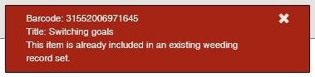
We have now inventoried around 90% of a given collection, in thirty days, with two to three staff, during operating hours.

Some additional SQL

Phase 0.0 – If you want to have inventory staff self-report statistics, or gauge collections suitable for inventory at a given moment, the following SQL will do the trick. This query checks a collection's ‘in’ count, contrasted with the total of items we will be looking for in the collection in Phase 3. Divide the ‘In’ count by the ‘Total’ count to get an estimate percentage of materials currently on the shelf:

Joining by CircItemRecords:

SELECT ItemRecordID
FROM ItemRecordDetails
WHERE Callnumberprefix IS NULL
AND LastInventoryDate IS NULL
AND ItemRecordID IN
(SELECT ItemRecordID
FROM CircItemRecords
WHERE AssignedCollectionID IN
(SELECT CollectionID
FROM Collections
WHERE Name LIKE 'nvarchar')
AND ItemStatusID = 1)

(for the total count of a collection, replace last line of the previous query with the following):

AND ItemStatusID NOT IN
(3, 4, 5, 12, 13, 15, 17, 18, 20, 22, 23))

Phase 1.5 - In especially large inventory areas where staff are unable to regularly work, this statement can be used to search for items in a given collection missed during the still-ongoing Phase 1 (an example of this would be Adult Fiction, at our library tens of thousands of items and difficult to dedicate staff to inventorying - so by the time we get to ‘C’ a host of returned material has come back to the shelves):

Organized intuitively (relatively speaking) and using the weeding record set name:

SELECT ItemRecordID
FROM CircItemRecords
WHERE ShelfLocationID NOT IN
(SELECT ShelfLocationID
FROM ShelfLocations
WHERE Description NOT LIKE '%NEW%'
)
AND ItemRecordID IN
(SELECT ItemRecordID
FROM ItemRecordDetails
WHERE CutterNumber BETWEEN 'nvarchar' AND 'nvarchar'
)
AND ItemRecordID IN
(SELECT ItemRecordID
FROM WeedingRecordSets wrs
INNER JOIN RecordSets rs
ON rs.RecordSetID = wrs.RecordSetID
WHERE rs.Name = 'nvarchar'
)

For Phase 3 inventory in spaces with multiple collections (for example, if your Adult and Young Adult audiobooks are interfiled):

SELECT ItemRecordID
FROM ItemRecordDetails
WHERE LastInventoryDate IS NULL
AND ItemRecordID IN
(SELECT ItemRecordID
FROM CircItemRecords
WHERE AssignedCollectionID IN (int, int))

By collection name:

SELECT ItemRecordID
FROM ItemRecordDetails
WHERE LastInventoryDate IS NULL
AND ItemRecordID IN
(SELECT ItemRecordID
FROM CircItemRecords
WHERE AssignedCollectionID IN (SELECT CollectionID FROM Collections WHERE Name LIKE 'nvarchar'))

For Phase 3 inventory once the NULL status is no longer applicable (that is, the ball's been rolling and you have already done inventory in this section before):

SELECT ItemRecordID
FROM ItemRecordDetails
WHERE LastInventoryDate <= DATEADD(YEAR, -1, CURRENT_TIMESTAMP)
AND ItemRecordID IN
(SELECT ItemRecordID
FROM CircItemRecords
WHERE AssignedCollectionID = int)

By collection name:

SELECT ItemRecordID
FROM ItemRecordDetails
WHERE LastInventoryDate <= DATEADD(YEAR, -1, CURRENT_TIMESTAMP)
AND ItemRecordID IN
(SELECT ItemRecordID
FROM CircItemRecords
WHERE AssignedCollectionID IN SELECT CollectionID
FROM Collections
WHERE Name = 'nvarchar'
))

Postscript Considerations

+ Awareness of library programs and events that impact circulation of collections must be noted when inventorying – collections in regular, rapid rotation being sequestered for periods of low activity.

+ Reporting for other purposes (SimplyReports weeding lists, principally) is potentially affected by this process, as the Inventory check in/bibliographic modification are classed by Polaris as circ activity. An adjustment of procedural from “Item Last Circ Activity Date” to “Item Last Check In Date”, or whichever specific action you are seeking to gauge by, will be in order.

+ Tracking progress of areas inventoried is an essential consideration. This being emphasized, data collection and reporting on inventoried status in given spaces is, understandably, independent of Polaris; and our own journey to clear data presentation has been a rocky one. Presently we are utilizing Google’s cloud-based Sheets to allow for multiple work station input.

+ As aforementioned, there is the potential to utilize ADHOC=”” function in CCL, which allows for SQL to be used in inclusion criteria as of 7.8. As of 8.0, we have merely dipped our toe into experimentation with these kinds of filters versus CCL; but tests have been promising save the following unfortunate formula: the greater complexity of the query, the greater likelihood of identifying cataloguing issues, the more time spent determining which and how many of your criteria are deficient. By way of positive example, one could potentially use an SQL template to seek out Graphic Novel materials missing 008 field data corroborating this item type (‘Illustrations’, substring datapoints 18-21 and ‘Nature of contents’, substring datapoints 24-27).

For example, no built-in comment lines or ORDER BY statements, along with major limits on the number of JOINS.
Access to weeding templates is a permission for any given Polaris User, and will not be available for general staff to see/edit/use. Local policy permitting, make sure your inventory staff have access to these credentials.
CCL presents some limitations which could only be surpassed by weeding templates being able to use SQL – which is technically possible in 7.8 given the 4,000-character limit. With CCL, the CALL search will not be able to determine whether call number info is in the Prefix, Classification, Cutter, of Suffix field – meaning inventory staff could screen an item whose call number is GRAPHIC NOVEL BATMAN BATMAN BATMAN without a system alert.
Bluetooth presented some data transmission issues for us, but is not impossible to use.
Adding directly from an Item Record Set, while tempting to use, outputs as error reports item control numbers, not barcodes - making it difficult for some staff to identify problem items. A suggested custom output option is on the Idea Exchange.
Excepting collections with a high circ rotation – as we learned, inventorying Youth collections during summer reading yields a mere 30% of the collection handled. Schedule wisely.
The ‘Count only’ box needs to be checked in the FIND tool.

