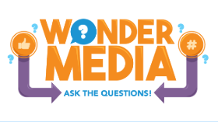
MLA-DLA Annual Conference 2026 Pre-conference
Wonder Media: Ask the Questions!
Media Literacy Resources

Wonder Media: Ask the Questions
AAP Family Media Plan
AI For Kids Podcast
Common Sense Media for Educators
Common Sense Media’s blog on Parenting, Media, and Everything In Between
Media Literacy in the Library: A Guide for Library Practitioners (a publication from the Institute of Museum and Library Services), 2020

Media Literacy Today: AI Literacy and Media Literacy: You Can’t Have One Without the Other

Peer Coaching Media Mentorship Toolkit (Maryland)
Becoming a Media Mentor: A Guide for Working with Children and Families, (ALSC)

Spotting Media Influence
Stop, Think, Connect
Three C’s: Content, Context, and Your Child (Lisa Guernsey)

