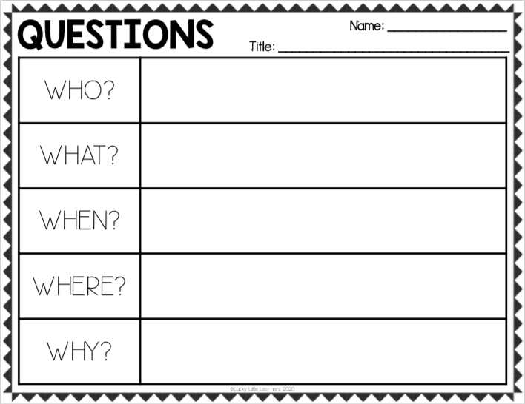
Use the other side to draw a picture from the story.

